Instructions on How to Register to Download Tenders
New EAC Website
Please be informed that the Electricity Authority of Cyprus (EAC) has proceeded with the upgrade of its website, effective as from 26/5/2014.
As a result, registration to Tenders and their management has changed.
Therefore, in order to continue receiving the amendments and clarifications of the Tenders you are already registered to, you are kindly instructed to register on the new EAC website and to also Download again the Tender Documents that are of interest to you.
Note that, on the new website you will only have to register once and your Username and Password will be valid for ALL Tenders. The user name is your email address and your password is a password you will decide upon (of your own choice).
Note also that, if you wish to receive Notifications regarding any amendments and clarifications related to a specific Tender you have to open the Tender that is of interest to you and Click on the “Download Documents”.

Registration to the New EAC Website
- Visit EAC’s website www.eac.com.cy

- Click on Sign In for registration to EAC website.

- Please proceed with the completion of the form.
If you wish to receive emails when a new Tender is published then check the box: I want to receive information regarding EAC Tenders.

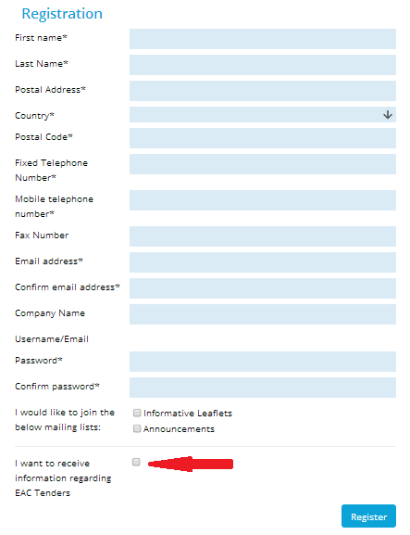

- On completion of the form click on Register.

Download Tender Documents
- In Order to Download Tender documents you have to Sign In to EAC’s Website.

Use the Username/Email - Password that you specified in your Registration Form.
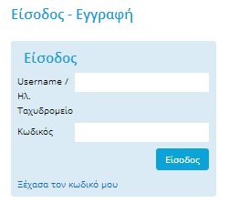
- On the menu click on TENDERS.
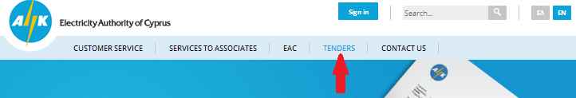

- Click on the Tender you are interested in and then Click Download Tender Documents.

- ATTENTION
By clicking "Download Tender Documents", you agree to receive Notifications regarding any amendments and clarifications related to this specific Tender.

- You may change the information you have given upon registration by modifying your “profile”

